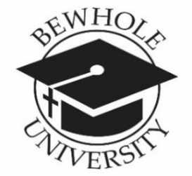

BEWHOLE UNIVERSITY-2021
Chancellor: Prophetess Bendetta Clark
Email: bwccuniversity@gmail.com
“Where becoming and being whole is our passion”

QUESTIONS

1. What is the name of the founder of Judaism and where is it found in the Christian Bible?

2. What is the names of Abraham’s son and grandson? Which of these had a name changed?

3. Judaism is the world’s oldest ________________religion?

4. Judaism believes there’s only one God? True or False

5. Judaism also believes that their Messiah has not yet come? True or False

6. Traditionally, a person is considered Jewish if his or her father is Jewish? True or False

7. Of, Jacob’s 12 sons, __________ had the role of leadership. At one point, he was the dominant tribe among those living in Israel, and the entire nation became known as Jews, and their creed, ______________.

8. The Hebrew means________________________, on the other side, and different from all others. Abraham was a solitary believer in a sea of idolatry.

9. _____________the leader who led the Jews out of Egypt and to whom G-d communicated in the presence of the people at Mount Sinai—recorded the story of creation and the history of Abraham’s family up until his time in what became______________, or the Five Books of Moses. In addition, the Torah also contains G-d’s instructions for personal and communal life.

10. For the Oral Torah, discussions were eventually written down, becoming the ______________,
___________________, and ___________________.

11. The Torah contains how many instructions? ____________

12. Practices among the Jews would include what 6 duties?

13. The Jewish holidays would include:

14. Judaism is the automatic religion of every Jew? True or False

15. Please list the 6 types or sects of Judaism?

